Checks and Questions Iridium Handheld

Questions
- Please identify your mobile (Card ICCID, MSISDN)?
- Please describe, step by step: what you are doing, what is not working, and at which moment.
- What is the terminal manufacturer and model?
- What is the software version used?
- Do you use an additional hardware? Which one?
- What is the power source (power adapter, battery, solar panel)?
- Is the GPS position up to date?
- Is your antenna signal strong and stable? How many bars?
- Did the terminal work before?
- Which service is not working and since when?
- Did you test the phone outside and in an open area?
- What is the error code or error message?
- Is the error message on the display or do you hear it?
- If the problem is shore to the Sat phone, which mobile operator is used?
- Data Usage:
  - Which operating system is used on the computer?
  - What link of interface are you using between the terminal and the PC (if any)?
  - How do you access the internet (dial up / Direct Internet)?

Checks
- Check the mobile status in SPNET, The Source.
- Check Call records in The Source.
- Check the antenna signal with the customer.
- Check that the number the customer is dialing is correct.
- Perform a test call (to and from mobile).

Quick Sheet for Troubleshooting
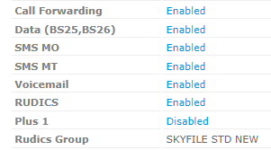
Default settings after activation to be checked within The Source:

- Voicemail and call forwarding must be enabled to have voicemail working.
- Data must be enabled to have data services working.
- RUDICS should be enabled with group selected as SkyFile STD.

